The Franciscans Unmasked at Last!!
The men behind the "Christian" masks

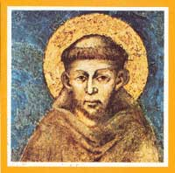  Francesco Bernadone (1181-1226) a.k.a. Saint Francis. |  | The Franciscans were the forerunners of the Jesuits. As a matter of fact, the Jesuits are just "warmed-over" Franciscans.  Francesco Bernadone, the founder of the Franciscans, was born in Assisi, Italy, in 1181.  Like Ignatius LIEola his youth was spent with wine, women and song. Like LIEola, he was taken prisoner in a battle between rival cities in Italy.  After the battle he had plenty of time to thing about his corrupt life so that was when his so-called "conversion" took place.  In 1209, he founded the Franciscan Order. The Order soon spread like the plague throughout the then known world. The 13th century was the MIDNIGHT of the Dark Ages . . . and the NOONDAY of the Papacy.
Francis read a verse in the New Testament where Jesus said:
"Sell that ye have, and give alms; provide yourselves bags which wax not old, a treasure in the heavens that faileth not, where no thief approacheth, neither moth corrupteth" (Luke 12:33).
He decided to take that verse literally and founded an order of monks based upon POVERTY, Chastity and Obedience. However, he conveniently ignored all the other verses that talk about charity and giving to the poor. Jesus said also:
"Take heed that ye do not your alms before men, to be seen of them: otherwise ye have no reward of your Father which is in heaven.
Therefore when thou doest thine alms, do not sound a trumpet before thee, as the hypocrites do in the synagogues and in the streets, that they may have glory of men. Verily I say unto you, They have their reward.
But when thou doest alms, let not thy left hand know what thy right hand doeth:
That thine alms may be in secret: and thy Father which seeth in secret himself shall reward thee openly.
And when thou prayest, thou shalt not be as the hypocrites are: for they love to pray standing in the synagogues and in the corners of the streets, that they may be seen of men. Verily I say unto you, They have their reward.
But thou, when thou prayest, enter into thy closet, and when thou hast shut thy door, pray to thy Father which is in secret; and thy Father which seeth in secret shall reward thee openly" (Matthew 6:1-6).
Francis of Assisi and Islam
In 1219, Francis of Assisi made a trip to Egypt and had a consultation with the Sultan Malik el-Kamil. After returning to Italy, he was so impressed by the PIETY of the Muslims prostrating themselves on the ground and praying to their false god Allah, and his prophet Mohammad, that he wanted to introduce a Roman Catholic version of the Islamic muezzin to call the FAITHFUL to prayer:
A Letter to the Rulers of the nations
"To all mayors and consuls, magistrates and rulers throughout the world, and to everyone who may receive these letters: Brother Francis, your little and despicable servant in the Lord God, sends [his] wishes of health and peace to all of you.
Pause and reflect, for the day of death is approaching (cf. Gen 47:29). I beg you, therefore, with all possible respect, not to forget the Lord or turn away from His commandments by reason of the cares and preoccupations of this world, for all those who are oblivious of Him and turn away from His commands are cursed (cf. Ps 118:21) and will be totally forgotten by Him (Ez. 33:13). And when the day of death does come, everything which they think they have will be taken from them (cf. Lk 8:18). And the wiser and more powerful they may have been in this world, so much greater will be the punishments they will endure in hell (cf. Wis 6:7).
Therefore, I firmly advise you, my lords, to put aside all care and preoccupation and receive with joy the most holy Body and the most holy Blood of our Lord Jesus Christ in holy remembrance of Him.
And you should manifest such honor to the Lord among the people entrusted to you that every evening an announcement be made by a town crier or some other signal that praise and thanks may be given by all people to the all-powerful Lord God. And if you do not do this, know that you must render an account before the Lord your God, Jesus Christ, on the day of judgment (cf. Mt. 12:36).
Let those who keep this writing with them and observe it know that they will be blessed by the Lord God" (Francis & Claire, The Complete Works, pp. 77-78).
Francis of Assisi wanted to get the Europeans praying like the Muslims....A dispute arose about whether the people should face Rome or Jerusalem when praying, so the plan was abandoned!!
No wonder he loved Islam because that false religion was started by the Vatican....It was the BEST ENEMY MONEY COULD BUY.... Islam had groups of "monks" which dressed and acted exactly like Roman Catholic monks. They were called SUFIS:
"The sultan's impartial reception is even more understandable, if one is aware of the existence then of a kind of ascetic Muslim fraternity. The members wore a reddish woolen cowl with a cord around their waist and lived from begging. Their motto was to possess nothing and be possessed by nothing. The Muslims venerated them. The Friars strangely resembled them. That no doubt explains, as Jacques de Vitry attests, the initial good reception by the Muslim population. These ascetics were called Sufis" (De Beer, We Saw Brother Francis, p.79).
Islam came to Spain via the Vatican!!
The false prophet Mohammad and his military machine was financed by the Vatican.... It was the best enemy money could buy....About 50 years after the birth of Islam, the Moslem armies conquered the MOORS in North Africa.
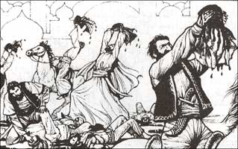  The final target of the Mohammedan hordes was Christian Spain. On their way to Spain, they massacred 50,000 Christians in the Moroccan city of Fez. The streets ran red with blood. The Muslim murderers dipped their caps in the blood in honor of Allah. These blood-stained caps were called FEZES. |  | The Final Target of MohamMAD and his military machine was Christian Spain. The Spanish Congregation was founded by the Apostle PAUL around 65 A.D.  St Paul said:  "Whensoever I take my journey into SPAIN, I will come to you: for I trust to see you in my journey, and to be brought on my way thitherward by you, if first I be somewhat filled with your company "(Romans 15:24).  "When therefore I have performed this, and have sealed to them this fruit, I will come by you into SPAIN" (Romans 15:28).
The Final Target of Islam was Christian Spain!!
In 711, the MOORS were INVITED to invade Spain....They were finally expelled in 1492.
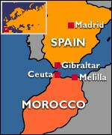  In 711, the Moors from Morocco conquered Spain from the Visigoths. |  | In the year 711, the MOORS from Morocco conquered Spain, and destroyed what was left of Christianity.  Immediately after the conquest of Spain, the church of Rome identified with Spanish nationalism and their just efforts to expel the invaders. At the same time, in standard duplicity, she supported the Moors.  The wars with the Moors turned Spain into a military state. It was a society organized for war....All the arts of war were perfected during this 800 year period e.g., the use of vicious dogs, the legend of El Cid the warrior, and the diabolical Inquisition.  Romanism, militarism, and Spanish nationalism were the unholy trinity in Spain for almost 800 years prior to Columbus.
After occupying Spain for 781 years, the Moors were miraculously expelled from Spain in 1492.... What a coincidence... This freed up the Spanish army and allowed them to be redeployed to the New World. This killing machine that was almost 800 years in the making was now unleashed on the naked, defenseless, New World natives.
A lot of intermarriage occurred between the Moors and the Spanish people. The original Spaniards were of Celtic origin and were white people. The Moors were black.
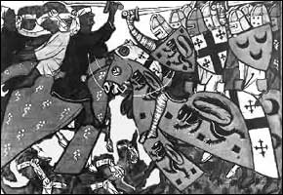  Muslim cavalry comes face to face with Spanish knights in this illustration from a manuscript dating from 1337. The Moors—the best enemy money could buy—were miraculously expelled just in time for the voyage of Columbus in 1492. |  | 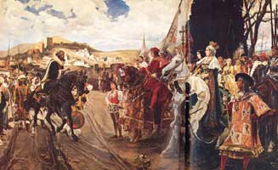  Surrender of the Moors to Ferdinand and Isabella in Jan. 1492, after occupying Spain for 781 years.....What a coincidence!!!!
Columbus was a Franciscan monk!!
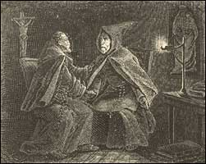  Columbus and Juan Perez |  | 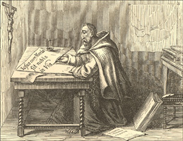  Columbus the Franciscan monk tries his hand at writing.

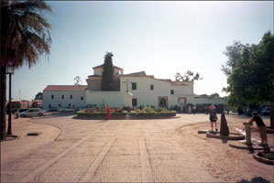  The Franciscan Monastery Santa María de la Rábida near Palos was the headquarters of Columbus during the preparation for his voyage of "Discovery." This was the nest where the plot was hatched to steal the New World from John Cabot and England. La Rábida is Arabian for hermitage, because it had once served as a Mohammedan place of retreat!! |  | 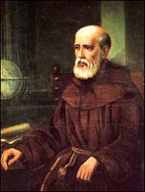  Franciscan monk Juan Perez de Marchena was head of the monastery. He was also the Queen's confessor. Friar Juan Perez was the liaison between the Catholic monarchs and Columbus and he agreed to arrange everything and get Columbus on his way as quickly as possible before Cabot's Discovery became know to the world.
POOR CLARE!!
You cannot have an Order of celibate monks without having an equivalent order of NUNS to take care of the needs of the monks!!
Poor Clare's misfortune was meeting Francis of Assisi. She was eighteen years of age when Francis came to preach the Lenten sermon in the church of San Giorgio at Assisi. She never read the verse in the Bible where Saint Paul said:
"I will therefore that the younger women marry, bear children, guide the house, give none occasion to the adversary to speak reproachfully" (I Timothy 5:14).
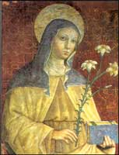  Poor Clare (1194-1253). |  | Poor Clare was born in Assisi, Italy, in 1194, and died in 1253. After meeting Francis, she disobeyed her parents and ran off to a Benedictine convent. Later she was the founder of an Order of nuns called the Poor Clares.  Nuns or vestal virgins are as old as mankind. Ancient Egypt had its virgins who took care of the needs of the celibate priests of Isis. Of course, pagan Rome had its vestal virgins who were forbidden to marry and tended the fire in the temple of the goddess Vesta.  The Great Inca historian, Garcilaso de la Vega described in great detail the lives of virgins dedicated to the sun and their vows of perpetual virginity.  What makes the Roman Catholic system so horrible is that the crimes are committed in the name of Jesus—the true God of the universe!!
Poor Clare established a number of rules for the Poor Clares. This Order was founded at the height of the Dark Ages and secrecy was not a concern because the Popes had all Europe under their iron heel. Back then the lack of reading skills didn't seem to bother the parochial school system:
"INNOCENT, BISHOP, SERVANT OF THE SERVANTS OF GOD, TO THE BELOVED DAUGHTERS IN CHRIST THE ABBESS CLARE AND THE OTHER SISTERS OF THE MONASTERY OF SAN DAMIANO IN ASSISI: OUR BEST WISHES AND APOSTOLIC BLESSING.
The Apostolic See is accustomed to accede to the pious requests and to be favorably disposed to grant the praiseworthy desires of its petitioners. Thus, we have before Us your humble request that We confirm by [our] Apostolic authority the form of life which Blessed Francis gave you and which you have freely accepted. According to [this form of life] you are to live together in unity of mind and heart and in the profession of highest poverty. Our venerable Brother, the Bishop of Ostia and Velletri, has seen fit to approve this way of life, as the Bishop's own letters on this matter define more fully, and We have taken care to strengthen it with our Apostolic protection. Attentive, therefore, to your devout prayers, We approve and ratify what the Bishop has done in this matter and confirm it by Apostolic authority and support it by this document" (Francis and Claire, The Complete Works, p.209).
CHAPTER THREE: THE DIVINE OFFICE AND FASTING, CONFESSION AND COMMUNION
"The sisters who can read shall celebrate the Divine Office according to the custom of the Friars Minor. They may have breviaries for this, but they should read it without singing. Those who, for some reasonable cause, occasionally are not able to recite their hours by reading them, may, like the other sisters, say the Our Fathers.
Those who do not know how to read shall say twenty-four Our Fathers for Matins; five for Lauds; seven for each of the hours of Prime, Terce, Sext, and None; twelve, however, for Vespers; seven for Compline. Let them also say for the dead seven Our Fathers with the Requiem aeternam at Vespers; twelve for Matins, because the sisters who can read are obliged to recite the Office of the Dead."
CHAPTER FIVE: SILENCE, THE PARLOR, AND THE GRILLE
"Let the sisters keep silence from the hour of Compline until Terce, except those who are serving outside the monastery. Let them also continually keep silence in the church, the dormitory, and the refectory, only while they are eating. They may speak discreetly at all times, however, in the infirmary for the recreation and service of the sick. Nevertheless, they can communicate always and everywhere, briefly and in a low tone of voice, whatever is necessary.
The sisters may not speak in the parlor or at the grille without the permission of the Abbess or her Vicaress. Let those who have permission not dare to speak in the parlor unless they are in the presence and hearing of two sisters. Let them not presume to go to the grille, moreover, unless there are at least three sisters present [who have been] appointed by the Abbess or her Vicaress from the eight discreets who were elected by all the sisters for the council of the Abbess. Let the Abbess and her Vicaress be themselves bound to observe this form of speaking. [Let the sisters speak] very rarely at the grille and, by all means, never at the door."
CHAPTER EIGHT: THE SISTERS SHALL NOT ACQUIRE ANYTHING AS THEIR OWN; BEGGING ALMS; THE SICK SISTERS
"Let no sister be permitted to send letters or to receive or give away anything outside the monastery without the permission of the Abbess. Let it not be permitted to have anything that the Abbess has not given or allowed. Should anything be sent to a sister by her relatives or others, let the Abbess give it to the sister. If she needs it, the sister may use it; otherwise, let her in all charity give it to a sister who does need it. If, however, money is sent to her, the Abbess, with the advice of the discreets, may provide for the needs of the sister."
CHAPTER TEN: THE ADMONITION AND CORRECTION OF THE SISTERS
"Let those who do not know how to read not be eager to learn. Let them rather devote themselves to what they should desire to have above all else: the Spirit of the Lord and His holy manner of working, to pray always to Him with a pure heart, and to have humility, patience in difficulty and infirmity, and to love those who persecute, blame, and accuse us, for the Lord says: Blessed are those who suffer persecution for the sake of justice, for theirs' is the kingdom of heaven (Matthew 5:10). But whoever perseveres to the end will be saved (Matthew 10:22)."
CHAPTER ELEVEN: THE CUSTODY OF THE ENCLOSURE
"Let the portress be mature in her manner of acting, discerning, and of a suitable age.Let her remain in an open cell without a door during the day. Let a suitable companion be assigned to her who may take her place in everything whenever necessary.
Let the door be well secured by two different iron locks, with bars and bolts, so that, especially at night, it may be locked with two keys, one of which the portress may have, the other the Abbess. Let it never be left without a guard and securely locked with one key.
Let them most diligently take care to see that the door is never left open, except when this can hardly be conveniently avoided. Let it never be opened to anyone who wishes to enter, except to those who have been given permission by the Supreme Pontiff or our Lord Cardinal. The sisters may not allow anyone to enter the monastery before sunrise or to remain within after sunset, unless a manifest, reasonable, and unavoidable cause demands otherwise."
The real reason for all the secrecy, iron locks and bars!!
A young girl is told that the cloistered convent is the closest place to Heaven on earth. Within its hallowed walls, she can escape the corruption of the world, and actually become the Bride of Christ. She is told that the life of a nun is a sure ticket to Heaven and that she can actually get her dead relatives out of purgatory by her prayers and penance.
She takes the bait and enter the convent.....Imagine her horror when the priest tells her that he represents Christ and that by becoming his lover she is married to Christ. Babies born by their union, and baptized by the priest, will go straight to Heaven, she is told, and in this way they are actually pleasing God by filling Heaven with innocent sinless souls!!!
By this time, escape is impossible....She must submit to the priest....the only alternative is a cruel death by her fellow nuns and the priests.
  Maria Monk, the author of this book, was one of the very few to escape from a cloistered convent. |  | Maria Monk was a young girl who entered the Hotel Dieu Nunnery in Montreal, Canada.  She saw it all: the lime pits for the babies' bodies, the secret passageways, the torture chamber, the book with the lists of babies born in the nunnery etc., etc.  She was pregnant with a priest's baby and she knew that immediately after its birth her baby would be smothered.  That was when she decided to make her escape. If she had lived in a Roman Catholic country, she would have been immediately arrested and sent back to the Nunnery and a cruel death.  In Protestant countries, it often happens that the Chief of Police is a Franciscan and a Knights of Columbus and an escaped nun would have little chance of evading her captors.
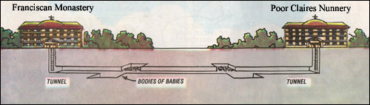
Tunnel connecting Franciscan monastery and Poor Claires nunnery in Spain.
According to ex-Jesuit priest Dr. Alberto Rivera, bodies of babies were found in Madrid, Spain, in 1932, and in Seville, Spain, in 1934. The governments of President Aznar and Manuel Azana demanded a national investigation of all Catholic monasteries, nunneries and church buildings in Spain.
Of course the Spanish Civil War started soon after the investigation began!!

Vital Links
Terror Behind Locked Door by Maria Monk
Francis of Assisi the Whirling Dervish
Peruvian Nuns by Garcilaso de la Vega, El Inca
The Rule of Poor Claire Online in pdf
Read the fascinating story of how Islam was formed
Francsicans turn Irish priest into an athiest!!
Franciscans committed terrible crimes against Serbs during WW II
Testimony of Sister Charlotte another escaped nun

References
Armstrong, Regis, J.,& Brady, Ignatius, C. (Translators) Francis & Clare, The Complete Works. Paulist Press, New York, 1982.
De Beer, Francis. We Saw Brother Francis. Franciscan Herald Press, Chicago, 1983.
Moorman, John. A History of the Franciscan Order: From Its Origin to the Year 1517. Oxford University Press, 1968.
Prescott, William H. The History of the Reign of Ferdinand and Isabella the Catholic. in 3 volumes, Philadephia, 1893.
Reed Rebecca & Monk Maria. Veil of Fear, Nineteenth-Century Convert Tales. Purdue University Press, West Lafayette, IN 1999.
Shah, Idres. The Sufis. Doubleday & Co., New York, 1964.

